**Probability and Statistics - IT2120**

**Lab sheet 07**

**IT NO: IT24102364**

**Name: Sanjana K.D.A**

Exercise

Q1

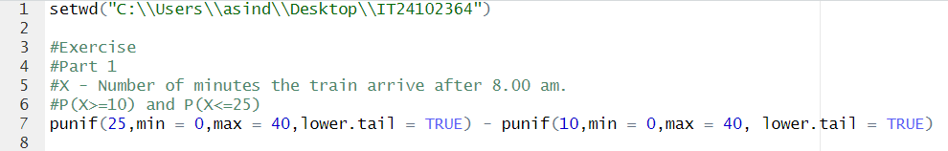

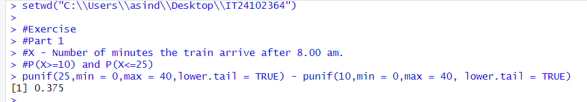

Q2

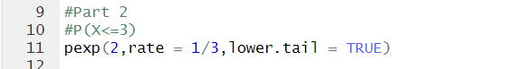

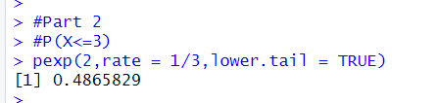

Q3

